GitHub Desktop (Version Control)
Table of Contents
WHAT IS GITHUB? 2
Setup and installations steps 2
A: If GitHub Desktop is not on the desktop 2
B: If GitHub Desktop is on your desktop / installed on your own laptop 5
The fundamental process 7
Create a new repository 7
Clone a repository 8
Commit and upload changes 9
Exercise 11

WHAT IS GITHUB?
GitHub is…

Setup and installations steps
This is only for university computers (not for MAE206). In MAE206 and other rooms, there is an icon for GitHub Desktop on the Desktop – open it from here and skip to step B.

A: If GitHub Desktop is not on the desktop
- Open Software Hub
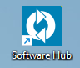
- Search for “GitHub Desktop” and click “Launch”
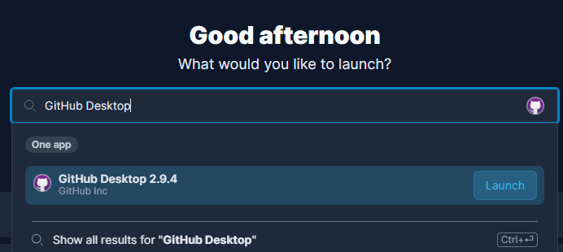

- Wait until the Status column is “Ready”
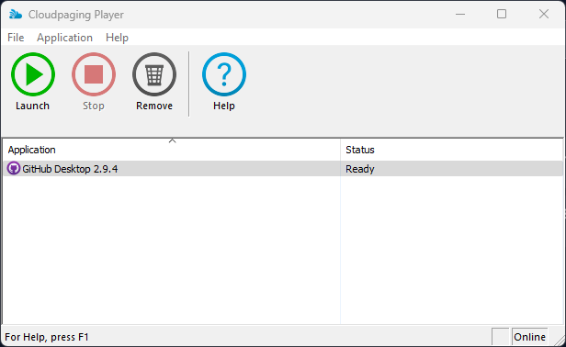

- Once GitHub Desktop has launched, click “Skip this step” under the blue button
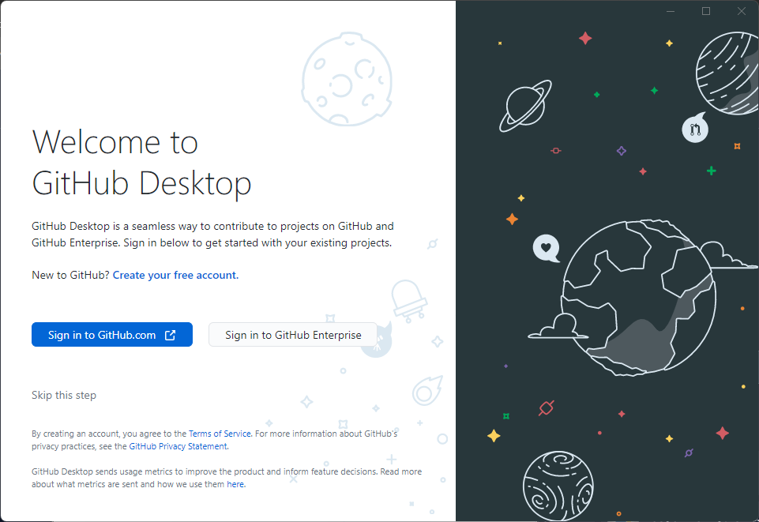
- Wait for your details to automatically appear and then click the “Finish” button
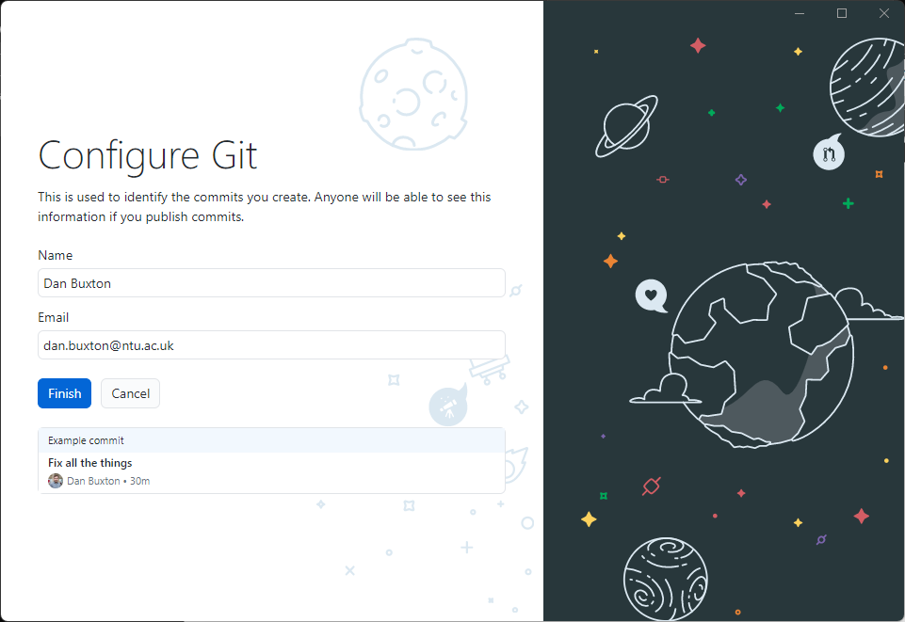
You should see the below. If not, ask you lab tutor, Dan Buxton.
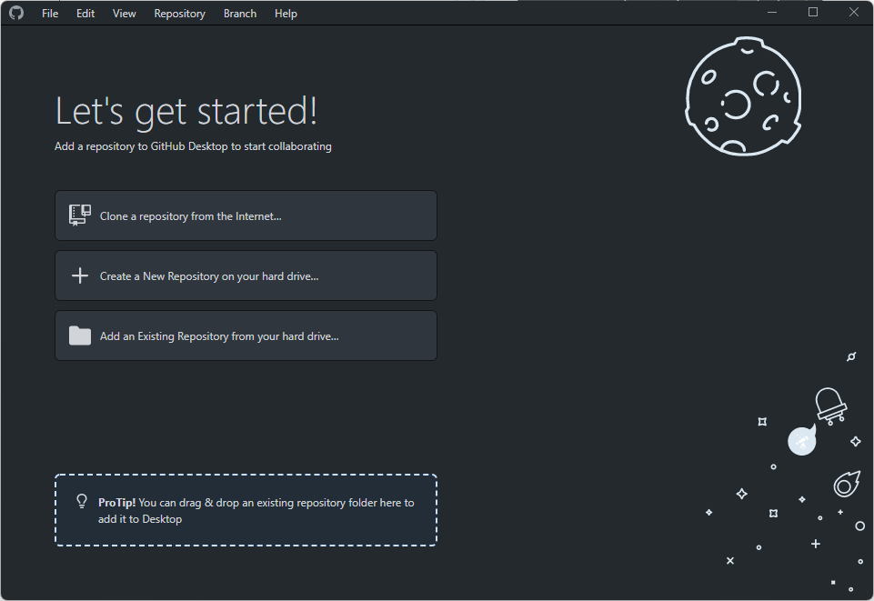

B: If GitHub Desktop is on your desktop / installed on your own laptop
- Open GitHub Desktop.
- Click the grey button labelled “Sign in to GitHub Enterprise”.
- Type “olympus.ntu.ac.uk” and click “Continue”.
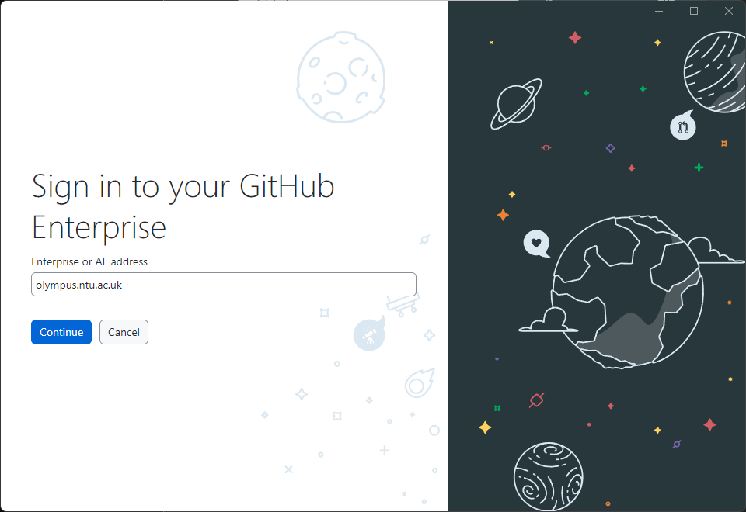
- Click “Sign in using your browser.
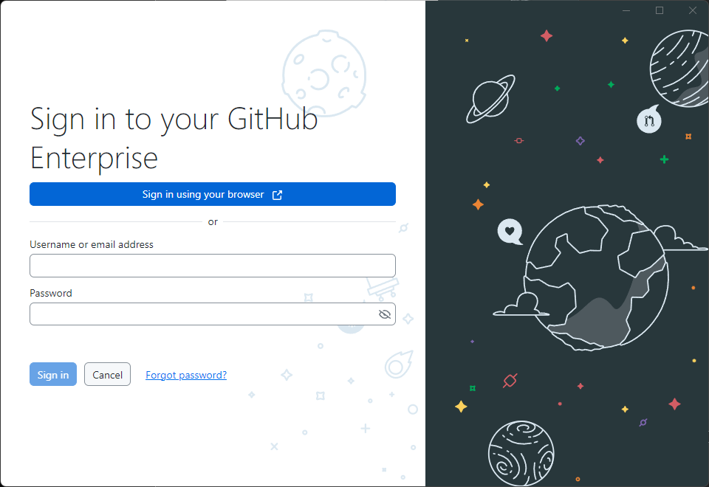
- Login with your NTU details, click continue and “Finish”, you should see something like the below.
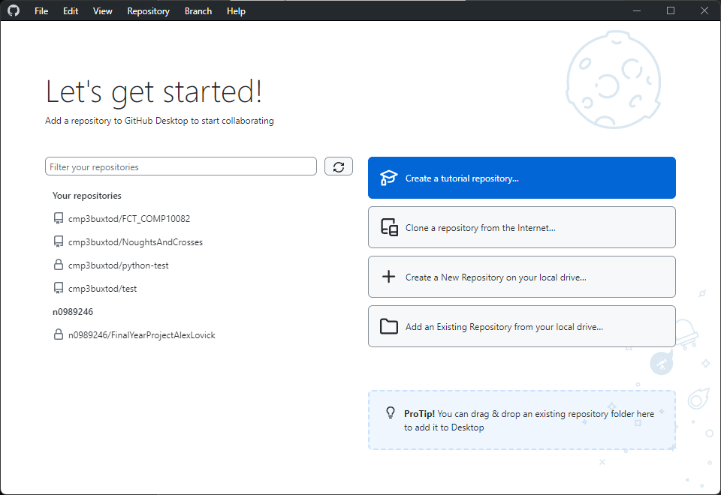

The fundamental process
This must be done in the correct order.
Visit: https://olympus.ntu.ac.uk and sign in.

Create a new repository
- Visit https://olympus.ntu.ac.uk/new
- Enter a repository/project name, make it public, and always add a README file
- Then click “Create repository”
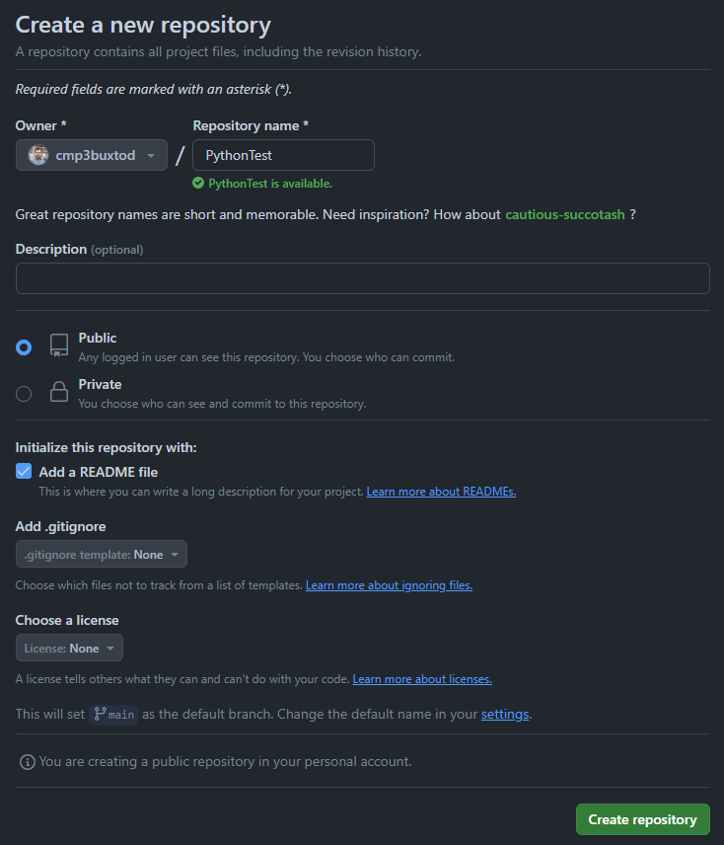

Clone a repository
- On GitHub Desktop, click refresh and double click the repository you just created.
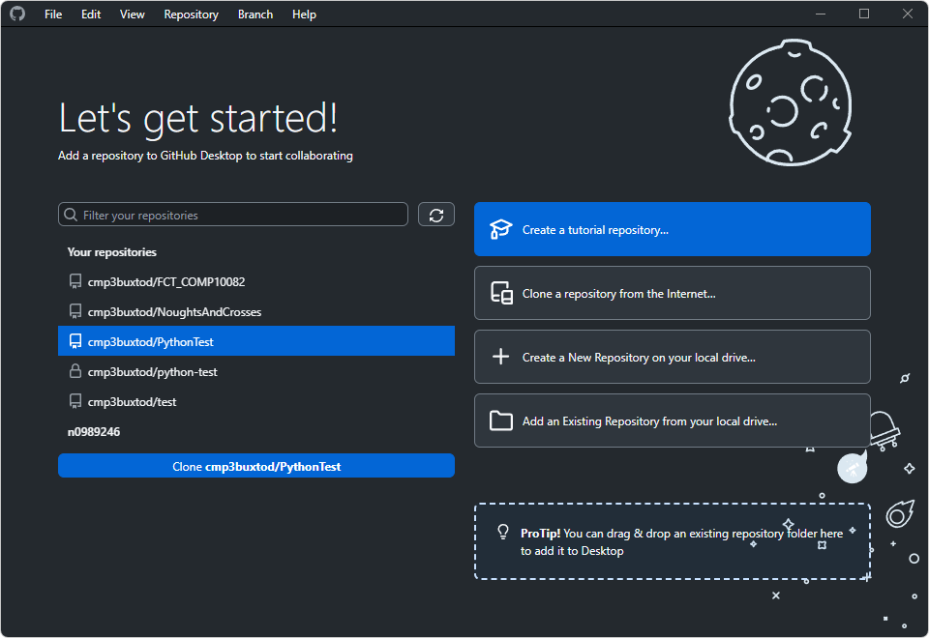
- A dialogue should open, choose your Downloads folder, as shown below, and click clone.
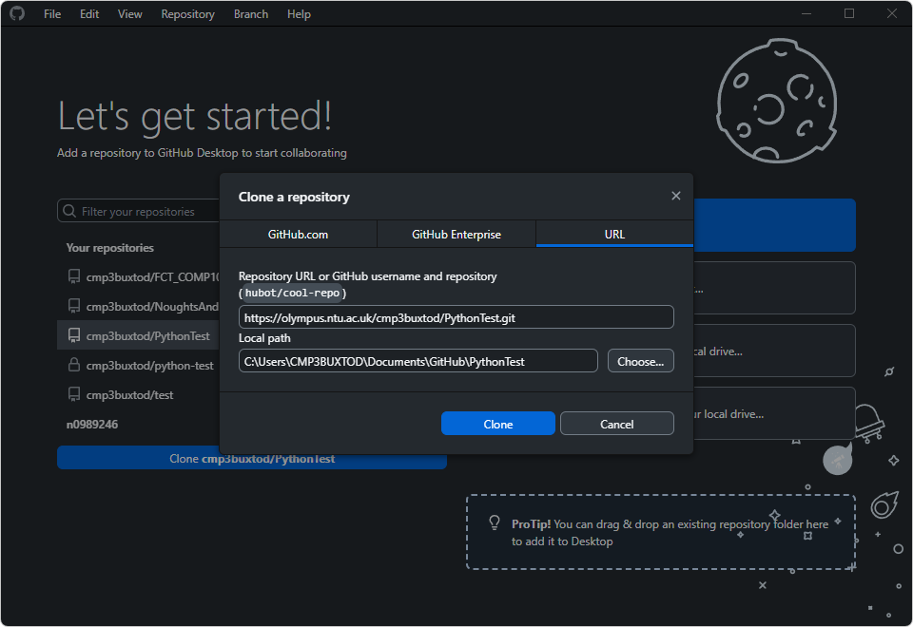
NOTE: The downloads folder is used in this demo but on NTU machines it is periodically emptied to free up space. Back up your work!

Commit and upload changes
Once you have added files to the repository folder, it’s time to save your changes.
All you need to do is add a summary message – this should be up to 1 sentence, preferably less. If you need to add more detail, this should go into the description.
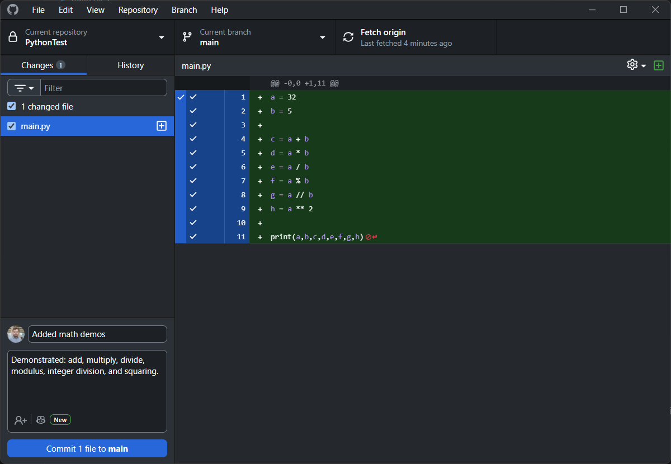
Then click “Commit to main”. This will make a ‘checkpoint’ locally on your computer. To access the change you just saved, you MUST “push” the changes/checkpoints made.
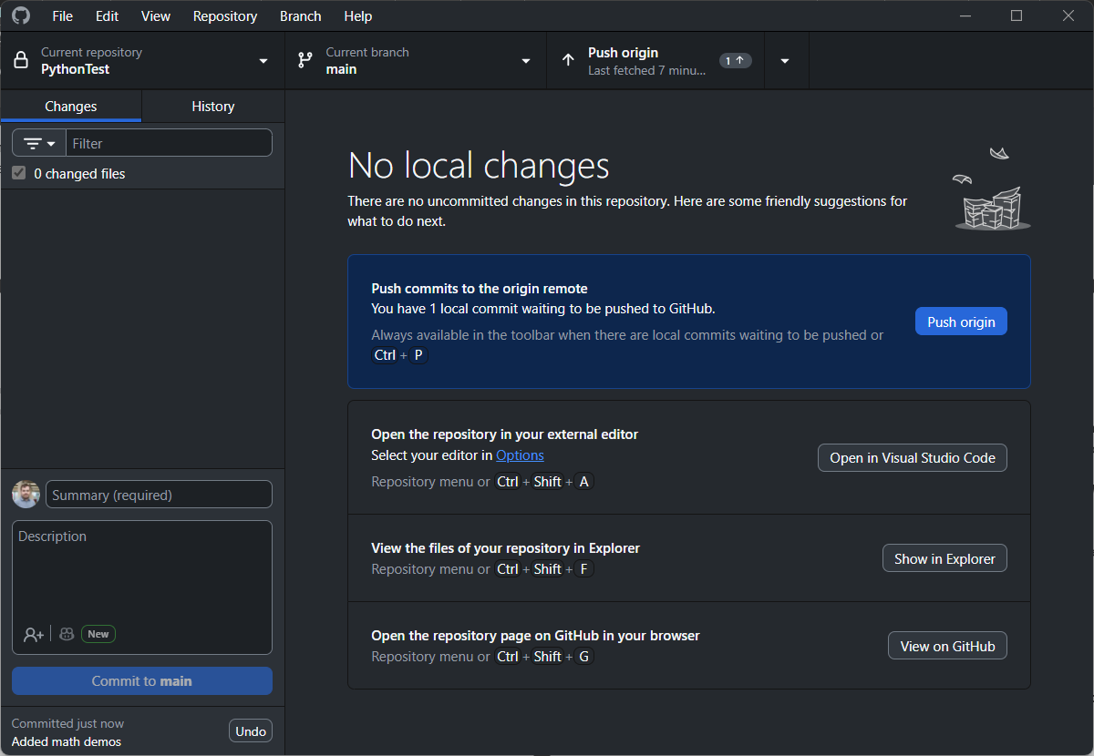
Back on Olympus, refresh the page and you should see your changes.
Before:
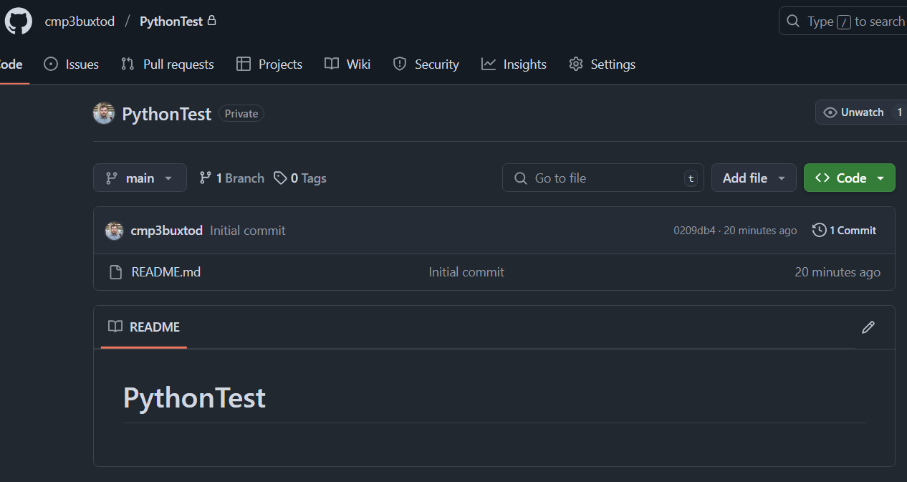
After:
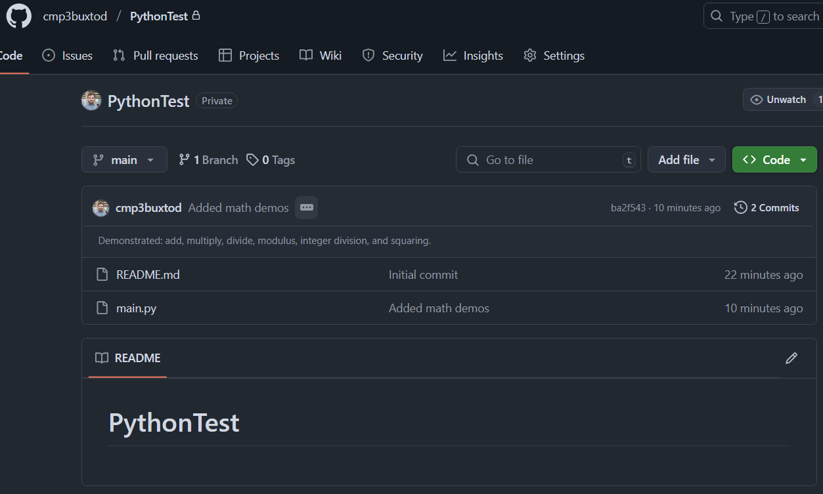

Exercise
- Create a repository called “SOFT40161_Intro2ComputerProgramming”
- Clone the repository to your computer. On NTU machines, this should be in C:\Users\USERNAME\Projects. Only code from an IDE like Visual Studio should be in the projects folder – notebooks work in any directory inside your user folder
- Move week 1 notebook into the repository folder
(LOCATION\ SOFT40161_Intro2ComputerProgramming\)
- Create a commit with a message “Added week n notebook”
- Push the commit and open olympus.ntu.ac.uk and check your notebook has been uploaded
- Repeat steps 3-5 for each previous week

Starting this week:
- Download the notebook for this week
- Move it to the repository folder and create a commit
- Create a new commit for each completed exercise or a function (that works!)

For each exercise in the notebook, there should be at least one commit.
From this week onwards, you must use GitHub to back up your work.
NOTE: You should be doing this for other modules as well!

